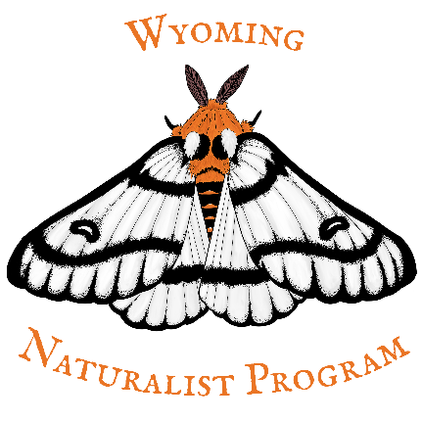
Does your non-WNP training qualify for your 8 hours of advanced training?

- Does this training improve upon foundational Wyoming Naturalist classes, and/or increase your knowledge of Wyoming's wildlife or wildlands?
- Yes… Continue to question 2.
- No… This training probably does not qualify. Contact a steering committee member with questions.
- Is this training required as part of a volunteer project?
- Yes… These hours count towards your volunteer hours, not advanced training.
- No… Continue to question 3.
- Is this training part of a conference?
  - Yes… Continue to question 4.
  - No… Continue to question 6.
- Is this training an informational presentation?
  - Yes… This training does not qualify for advanced training hours.
  - No… Continue to question 5.
- Is this training a skill-building or knowledge improvement workshop?
  - Yes… This training qualifies for advanced hours. See question 7 for limitations of hours applied.
  - No… This training does not qualify for advanced training hours.
- Is this training part of an online or work-at-your-pace course?
  - Yes… Continue to question 7.
  - No… This training qualifies for advanced training hours. See question 7 for limitations of hours applied.
- Have you completed more than 50% of your advanced training outside of the WNP?
  - Yes… This training does not count towards your training. Wyoming Naturalists may only use 4 advanced training hours from programs outside of the WNP.
  - No… You may earn up to 50% of your advanced training hours (4 hours) from non-Wyoming Naturalist Program training.

